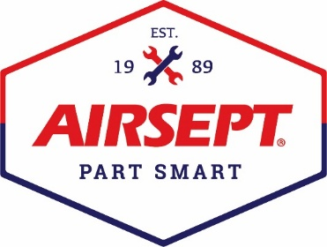

News Release

AirSept® Smart Splice® EZ-Port Adapters™
Win a 2026 MOTOR Top 20 Award

Atlanta – September 2, 2026 – AirSept®, manufacturer of Smart Splice® Repair Kits and other innovative time-saving tools for automotive service repair, is pleased to announce that its newly introduced Smart Splice EZ-Port Adapters™ developed for A/C refrigerant retrofit service, have received a 2026 MOTOR Top 20 Award.

Smart Splice EZ-Port Adapters offer a snap-on fit, with no special tools needed, for easy retrofit to next-generation refrigerants, e.g., from R-1234yf to R-444A or from R-134a to R-456A. The port adapters stay on the vehicle for future service needs and easy access. Durable and leak-proof, they eliminate concerns A/C service technicians may have about refrigerant cross-contamination. These patent-pending adapters meet the strict MVAC industry design requirements for high- and low-side port adapters to provide a safe refrigerant retrofit process.

AirSept president and owner, Aaron Becker, says, “We are honored to be recognized by MOTOR Information Systems for another technician-friendly tool designed to save time and money. With the EPA’s phase-down of HFCs and HFOs, it became apparent that their rule for using next-generation low-GWP refrigerants would require special adapters for the high and low ports to prevent cross-contamination. We’re very proud that we have found an innovative solution and that so many people in the industry voted in support of our product. We feel honored to introduce this new product with a MOTOR Top 20 award.”

AirSept Smart Splice EZ-Port Adapters are available for purchase now at www.airsept.com. To order, call 678.973.2286 or email information@airsept.com. Adapters are available as a set, high- and low-side ports, for R-1234yf conversion to R-444A or R-134a to R-456A.

For more information on AirSept’s full product line, visit AirSept.com or follow AirSept on Facebook or X. To learn more about the MOTOR Top 20 Awards and view all the 2026 winners, visit Motor.com.

# # # #

Image Attached: 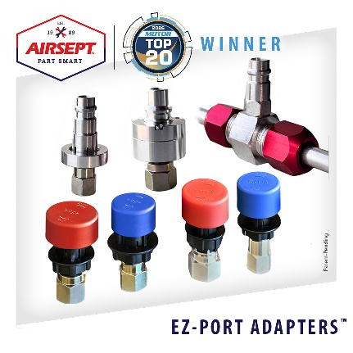

Caption: MOTOR Information Systems Recognizes AirSept® Smart Splice® EZ-Port Adapters™ with a MOTOR Top 20 Award

About AirSept®
In 1989, AirSept® created the first long-lasting solution to the problem of unwanted mold and mildew odor in automobile air conditioning systems. The product quickly became popular, and in 1991, AirSept was incorporated as a company. AirSept began partnering with global OEMs and suppliers to not only market its Cooling Coil Coating, but also to develop other unique, new problem-solving products. From those humble beginnings, AirSept has grown to be the industry leader in the development of OEM and aftermarket solutions to complex automotive repair problems. AirSept products are designed to save time, money, and labor. For more information, visit www.AirSept.com.

About MOTOR Information Systems
Founded in 1903, MOTOR Information Systems is one of the world’s premier suppliers of automotive data. MOTOR empowers the industry with trusted, comprehensive solutions spanning service and repair information, parts data, labor times, vehicle configurations, and market insights. A Hearst company, MOTOR continues to drive innovation and efficiency across the automotive ecosystem. Learn more at MOTOR.COM.

For further product information, contact:
Aaron Becker, President
AirSept
678-973-2287
abecker@airsept.com

Leslie Allen
Owner
Wildcat Communications
615-429-7965
leslieallen.wildcat@gmail.com

